**Autonomous Surveillance and Mapping Quadcopter**

**Group members**

James Brown, email: jcb60@students.uwf.edu

Bhavyansh Mishra, email: bm37@students.uwf.edu

Scotty Peirce, email: scp19@students.uwf.edu

Bryan Powell, email: bp30@students.uwf.edu

**Team Leader**

Bhavyansh Mishra

**Speciality Advisor**

Dr. M. Khabou

**Course Instructor and Advisor**

Dr. T. Gilbar

Capstone Design I

EGN4950L

Fall 2018

We certify that this assignment is the result of our own efforts.

*Abstract -* A quadcopter intended to be capable of mapping, navigation and data collection in an unknown environment was designed and constructed in this project. This aerial robot was designed to be able to perform the mapping, localization and path-planning algorithms entirely on-board. An off-the-shelf quadcopter was retrofitted with a single-board computer, light detection and ranging (LiDAR) sensors, and updated inertial measurement unit (IMU) equipped flight control module. Algorithms for path-planning and obstacle avoidance are developed and tested in simulated environments and integrated into an open-source PID-based quadcopter control stack named PX4. System monitoring algorithms were designed to allow the robot to adapt to variables such as low battery or system malfunctions. The resulting software infrastructure is tested, in combination with the hardware components, in controlled real-world environments. Hardware limitations prevent full execution of intended services.

Table of Contents

1. Introduction Page 1
2. Problem Definition Page 1
   1. Problem/Need Page 1
   2. Intended user(s) and use(s) Page 1
   3. Assumptions and limitations Page 1
   4. Design Objectives Page 2
3. Design Specifications Page 2
4. End-Product Description Page 2
5. Design constraints Page 2
   1. Economical Page 2
   2. Environmental Page 2
   3. Social and Political Page 3
   4. Ethical Page 3
   5. Health and Safety Page 3
   6. Manufacturability and Sustainability Page 3
6. Engineering Standards Page 3
7. Technical Approach Page 4
   1. Functional Block Diagrams Page 4
   2. Functional Requirements for Blocks Page 4
   3. Technical Details of Implementation Page 6
      1. Theory and Calculations Page 6
      2. Flow Charts Page 11
      3. Schematics Page 12
      4. Simulations Page 12
   4. Brief Discussion of Other Technical Approaches Considered Page 13
8. Part List and Budget Page 13
9. Gantt Chart Page 13
10. Testing Approach Page 15
11. Final Product/Project Results Page 16
12. Flow Chart of Design Process Page 16
13. Conclusion Page 16
14. Assessment of Topics Page 16
15. Team Activity Report Page 17

Bibliography Page 19

Appendix A (Resumes and Team Member Profile Forms) Page 20

Appendix B (CAD Designs) Page 30

Table of Figures Page 31

Table of Tables Page 32

1. Introduction

Recent advancements in robotics and diminishing costs of manufacturing robots have exhibited tremendous promise in achieving human-level performance at several routine tasks. The agility and recently achieved sophistication of various kinds of robots make them the ultimate alternative for human responders in hazardous conditions. Flying robots and quadcopters are particularly agile types of robots that can perform certain tasks such as surveillance, environment mapping, and monitoring excellently.

The purpose of this project is to design and build a robotic quadcopter with on-board capabilities of autonomous localization, mapping and path-planning. The objective of the quadcopter is to navigate from a known location to inaccessible parts of a building where conditions may be uncertain and any wireless communication unreliable. This drone performs rudimentary surveillance of the desired location in the building through the use of remote control. The quadcopter incorporates system monitoring capabilities that allow it to detect low battery conditions.

1. Problem Definition
   1. Problem/Need

Catastrophic events and disasters occur sporadically and result in varying extent of damage, operational delays and fatalities. In such situations, environmental hazards such as toxic fumes, heat, hostile threats, darkness, flooding and radiation can obfuscate the monitoring systems from humans and render the mission-critical operations defunct. Such incidents range from nuclear disasters such as Fukushima Daiichi [1], Chernobyl [2], and the Bhopal [3] to hostage situations and tactical military operations. Commonly, operational capability of humans is limited due to unknown floorplans and other environmental variables. This leads to delayed response time, and potentially fatal results. Such situations demand a more dispensable technique for first responders to perform surveillance and mapping of the affected building structures before an action plan can be devised.

* 1. Intended user(s) and use(s)

The outcome of this project will be an autonomous quadcopter device that could be dispatched by first responders such as firemen and policemen into buildings affected in the events of natural and man-made disasters such as nuclear disasters, terrorist attacks, hostage situations, building fires, etc. The quadcopter device will allow the first responders to capture invaluable data about the latest indoor state of the building during conditions dangerous to human responders such as poisonous or inflammable gases, nuclear radiation, flash floods and the alike. The quadcopter device will retrieve a reliable 2D map of the building layout.

* 1. Assumptions and limitations

Assumptions

1. Doorways and entry points are wider than 300mm
2. Floors are level so that the roof doesn’t slope down, causing the quadcopter to falsely read the roof as a wall.
3. Dynamically moving obstacles do not affect course of flight
4. External communication will not be possible,

Limitations

1. The quadcopter will be limited by its flight time
2. The quadcopter will rely solely on its on-board computations to complete the mission
3. The user will not know the condition of the quadcopter until it has either returned or reached a place where it can communicate back with the personnel.
4. The quadcopter will not be equipped to detect glass or mirror surfaces
   1. Design objectives

An off-the-shelf quadcopter will be retrofitted with depth sensors, upgraded flight control hardware, and on-board computation capabilities. Algorithms and techniques to perform simultaneous localization and mapping (SLAM) and path-planning were modified and designed alongside auto-pilot and flight control systems to allow the robot to avoid obstacles and efficiently explore an unknown environment.

1. Design Specifications
2. Increasing the flight time of the quadcopter by implementing an upgraded propulsion system and optimizing the payload weight.
3. The frame must be small enough to fit through most entry ways. The mechanical and electrical noise generated by components on the quadcopter, such as the propellers, LIDAR, raspberry pi, and battery must not interfere with each other to prevent malfunction.
4. The LIDAR’s laser has to clear all other components on the quadcopter frame, while also not interfering with propellor operation.
5. End-Product Description

Sending response teams into unknown structures poses a threat to equipment and safety. First responders such as firefighters and tactical teams often need to develop plans based on the layout of the building they are entering. The Autonomous Surveillance Quadcopter, or ASQ Bot, can operate without active user control to gather important video and blueprint data for an unknown building. The data gathered during flight is processed on-board and a 2D floor plan is rendered and returned to a safe location outside the structure. The ASQ Bot is a ready to fly quadcopter that uses proprietary intelligence software to provide needed eyes inside a building when responders need it most.

1. Design Constraints
   1. Economical

The project will be limited to parts and software that are readily available to the general public and must meet a budget of less than $1000. Once a final working prototype has been obtained, efforts will be focused on reducing the manufacturing costs for the system. Optimizations in the cost to performance will be considered in all the mechanical, electrical, computer and interfacing aspects of the project.

* 1. Environmental

This quadcopter will operate indoors keeping environmental impacts to a minimum. Due to being electrically powered, no harmful emissions or radiations will be generated. Propeller guards will be used to prevent damage to the surroundings that can be caused by rotating blades. Damaged LiPo batteries will be disposed off properly and safely..

* 1. Social and Political

Currently under Section 336 of the FAA Modernization and Reform Act of 2012, the FAA is prohibited from promulgating any mandatory regulations regarding recreational drone use. In May of 2017, the U.S. Court of Appeals case No. 15-1495 deemed a December 2015 FAA rule, that outlined registration and marking requirements for small unmanned aircraft, as illegal and vacated its authority.

With the new FAA Reauthorization Act of 2018 in the works, the Special Rule for Model Aircraft presented in Section 336 of the Reform Act of 2012 is up for repeal. As the project matures, any changes in the federal regulations will be noted and accommodated.

There are rising social concerns with the use of drones in public and the danger they can present when a malfunction occurs or when inexperienced pilots lose control of the vehicle. These concerns are mitigated in the scope of this project due to all testing and operations being performed indoors and in areas where no humans, other than the researchers, are present.

* 1. Ethical

Video equipped drones can be capable of violating the privacy rights of individuals if used improperly. Similar to the social concerns, most ethical concerns are eliminated due to the nature of operation for this project. Any and all video captured by the quadcopter will be filtered for any violations of privacy and will only be used for disaster management purposes by first responders. In the current iteration, no video- or audio-recording technology is installed. Additionally, since the quadcopter is capable of storing data, it will not be tested or used in areas containing classified, proprietary, or otherwise sensitive information. Testing environments will be monitored by staff with the authority to approve initial testing, and be given the opportunity to review information produced by the quadcopter to ensure no breaches of sensitive information have occurred.

* 1. Health and Safety

The 360 degree LiDAR module used in this project uses a low power, small wavelength, Class I laser emitter that is deemed by the Code of Federal Regulations Part 1040 as “safe under all conditions of normal use.”

Since the quadcopter will be used indoors, propeller guards will be employed to minimize potential harm to people and damage to property. Additionally the ASQ Bot will be tethered during testing until the flight control algorithm is stabilized.

* 1. Manufacturability and Sustainability

This design will utilize hardware components and software that are readily available to the general public. It will be in prototype form and all mounting solutions will be modified from the original quadcopter or custom designed and 3-D printed. Any level of manufacturability would require the sourcing or manufacturing of a proprietary quadcopter frame and propulsion system.

This system is designed in a rapidly evolving field, therefore, consumers will be motivated to frequently upgrade their existing platform. New and improved versions would provide a promising future of market sustainability.

1. Engineering Standards

IEEE P7008 is the standard responsible for robotic, intelligent, and autonomous systems overt or hidden suggestions. This standard is necessary to ensure these types of systems will not negatively affect human life by making a harmful decision the programmer did not account for. In our case, the quadcopter must choose a safe path and be able to avoid colliding with a human.

IEEE P7009 is the standard responsible for fail-safe design of autonomous and semi-autonomous systems. Autonomous systems must have a fail-safe for scenarios where the system does not operate as it was intended and worst case situations so that it can fail safely. The quadcopter we are designing will be programmed to detect uncontrolled flight when the frame is significantly non-horizontal and kill the path planning algorithm and start the hover function to become stable, then resume flight.

IEEE P7010 is the standard for how artificial intelligence and autonomous systems can improve the well-being of human life. Programmers should consider when designing an intelligent or autonomous system how it can benefit human life. The purpose of our project is to give first responders a tool to check the dangers present in a building before they they enter. This will give them an idea of what obstacles they will face before having to face them, which will allow them to prepare themselves, and reduce the chances of them being harmed.

1. Technical Approach
   1. Functional Block diagrams.

The major task division can be seen in Figure 7.1.1. The technical breakdown of the project has been split into five major groups with each member responsible for one part individually, and all group members coordinating for Hardware Interfacing.

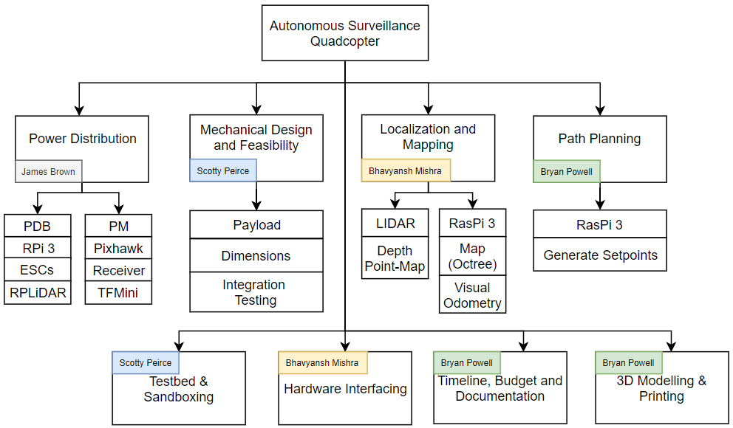

**Figure 7.1.1 Functional Block Diagram**

* 1. Functional Requirements for Blocks

**Table 7.2.1: Functional Requirements and Specifications for Power Distribution**

|  |  |
| --- | --- |
| **Requirements** | **Specifications** |
| Functional Requirements | Power source, battery eliminator circuitry (BEC), voltage regulation, connectors/adapters |
| Performance Requirements | High capacity battery storage, battery back-ups, low power components, appropriate wire and connector gauging |
| System Interaction | Facilitates the transfer of electrical power from source to powertrain and computational components |
| Operator Interaction | Circuit design and analysis, battery replacement, component selection |
| Hardware/software interface | Direct soldering, connectors, adapters |

**Table 7.2.2: Functional Requirements and Specifications for Mechanical Design and Feasibility**

|  |  |
| --- | --- |
| **Requirements** | **Specifications** |
| Functional Requirements | Small enough dimensions to fit through door and entryways, ability to lift payload |
| Performance Requirements | Long enough flight time, low enough payload weight, large enough thrust from motors/propellers/escs. |
| System Interaction | Supports computational and electrical components accompanying sensors used to perform navigation |
| Operator Interaction | Initial flight testing for performance and calibration |
| Hardware/software interface | Dampening to reduced vibrations to sensors, supports wiring and is controlled by signals sent to ESCs |

**Table 7.2.3: Functional Requirements and Specifications for Localization and Mapping**

|  |  |
| --- | --- |
| **Requirements** | **Specifications** |
| Functional Requirements | Provides a reliable estimate of the location. Generates a 2D map of the floor layout inside the building. |
| Performance Requirements | Needs to run on computationally-limited microcontroller platform on-board. SLAM is required to operate in real-time with 5 Hz update frequency at least. |
| System Interaction | Provides the localization estimate to the EKF running on the ArduPilot stack. Provides the 2D map (occupancy grid) for the Path-planning algorithm to operate on. |
| Operator Interaction | Requires manual configuration of the ArduPilot EKF parameters before launch of flight using a Ground Control Station software. |
| Hardware/software interface | The LIDAR module interacts with the flight computer using USB. The ROS package “hector_slam” provides output in form of ROS messages. |

**Table 7.2.4: Functional Requirements and Specifications for Path-Planning**

|  |  |
| --- | --- |
| **Requirements** | **Specifications** |
| Functional Requirements | Generate waypoints based on the occupancy grid provided by the Localization and Mapping block. Offer the waypoints to the ArduPilot stack for exploration of the building. |
| Performance Requirements | Needs to generate safe waypoints for the quadcopter to traverse. Keep track of the past waypoints for convenient tracing during return flight. Operate in real-time on computationally limited on-board computer. |
| System Interaction | Interacts with the ArduPilot stack to access the reference frame and provide the waypoints in the Map frame using ROS interface. Needs information regarding dynamics of the robot to perform path smoothing. |
| Operator Interaction | No operator interaction required |
| Hardware/software interface | Requires the occupancy grid that is generated by the SLAM algorithm. Outputs physical waypoints to the ArduPilot. |

* 1. Technical Details of Implementation
     1. Theory and Calculations

1. Power Management

The distribution and management of power throughout the quadcopter was implemented with a large consideration on efficiency. The small platform required to achieve indoor quadcopter operation and its dependence on an on-board battery source means the robot has very limited power capacity.

As the table below indicates (Table 7.3.1) the estimated maximum instantaneous power requirement of all onboard components totals 1190.5 watts.

**Table 7.3.1: Max system power requirements**

|  |  |  |  |
| --- | --- | --- | --- |
| Component | Max Current (A) | Voltage (V) | Power (W) |
| Propulsion | 80 | 14.8 | 1184 |
| RPLiDAR | 0.5 | 5 | 2.5 |
| Pixhawk | 0.5 | 5 | 2.5 |
| RasPi 3 B+ | 0.2 | 5 | 1 |
| Receiver | 0.1 | 5 | 0.5 |
| Total |  |  | 1190.5 |

The “C-rating” of a battery indicates the maximum current the battery can safely provide by multiplying the C-rating value with the total capacity of the battery. The batteries used during testing for our project are 1800 mAh rated at 50C. Therefore, Max current = 1.8 Ah * 50C = 90 A at the nominal 14.8 V, or 1332 watt. This is sufficient enough to begin testing. Larger capacity battery sources are readily available and can provide “plug and play” increases if necessary.

Preliminary testing revealed flight times of approx 12 minutes with EMAX 2212 935kV motors, 8045 propellers, BLHeli 20A ESCs, 1800mAh 4s LiPo battery, and all necessary hardware onboard and powered (this testing is further explored in the “mechanical design and feasibility” section of this report). Many efforts were made to keep weight to a minimum including shortening wires, removing all unnecessary frame components, and selecting lightweight hardware.

The following figure (Figure 7.3.1) details the architecture of power distribution throughout the quadcopter.

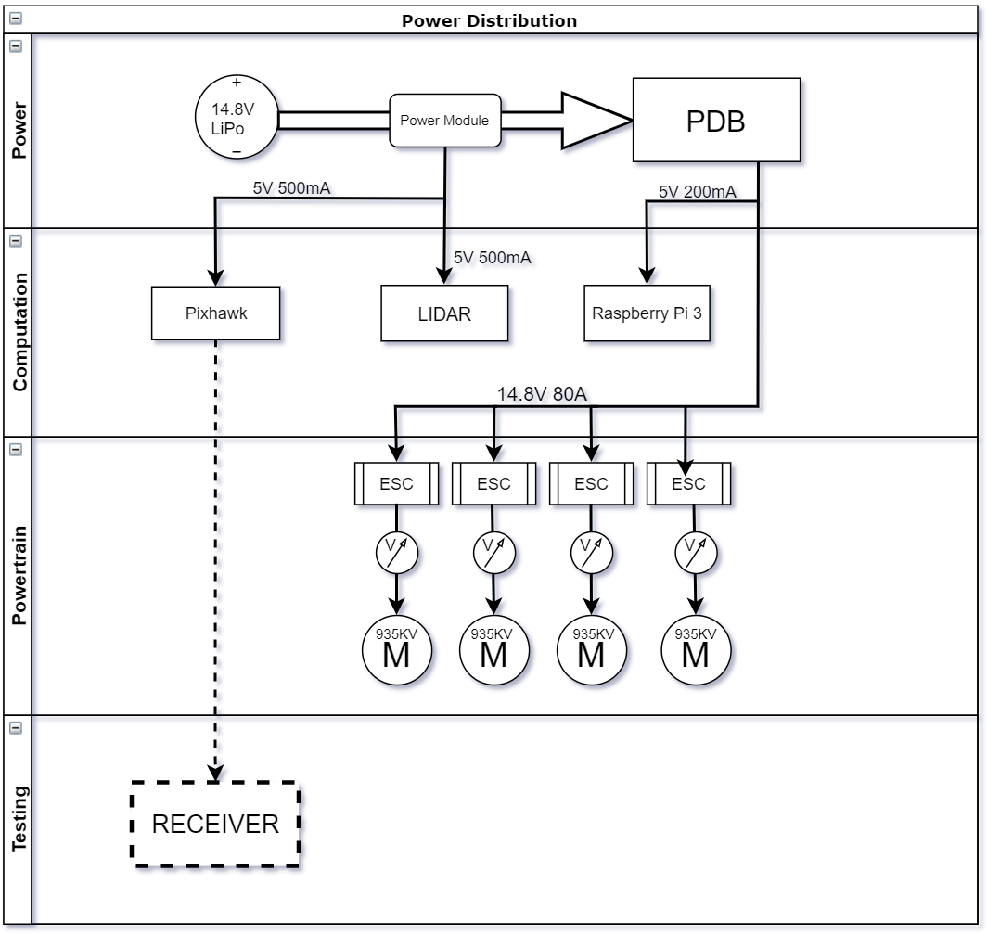

**Figure 7.3.1: Architecture of Power Distribution and Flow**

The proprietary 5.3 V 2.25 A power module is used to power the Pixhawk and 2D LiDAR module. The Matek PDB-XT60 power distribution board (PDB) is used to power the four electronic speed controllers (ESCs) at up to full battery voltage. A 5 V BEC located on the PDB is used to provide power to the Raspberry Pi companion computer.

Ground wires from Raspberry Pi, Pixhawk, LiDAR devices, and FTDI chip were connected through the same grounding bus to allow for a common reference point of communication when UART and USB serial protocols are passed from one device to another.

b. Mechanical Design and Feasibility

**Mechanical Design**

Constructing a quadcopter for efficient flight requires proper distribution of the weight and volume of the on-board components. Therefore a custom payload bay needs to be designed and 3D printed to host the Navio2, Raspberry Pi and the power distribution board on the quadcopter frame. The following illustrates the 3D design that will be used to create the payload-bay bracket piece.

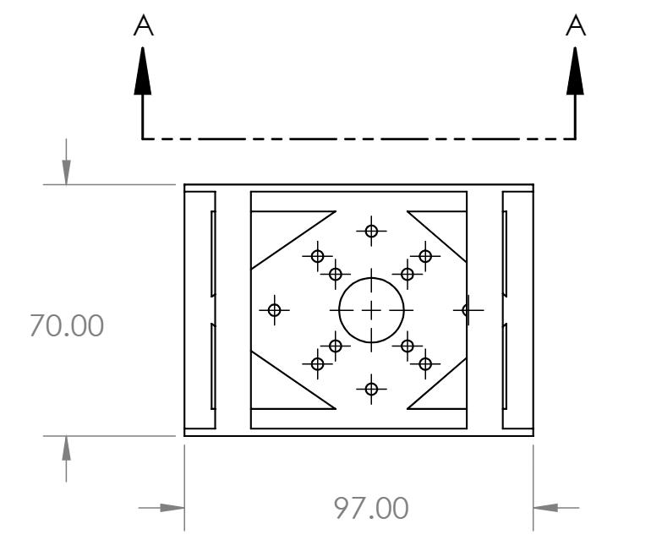

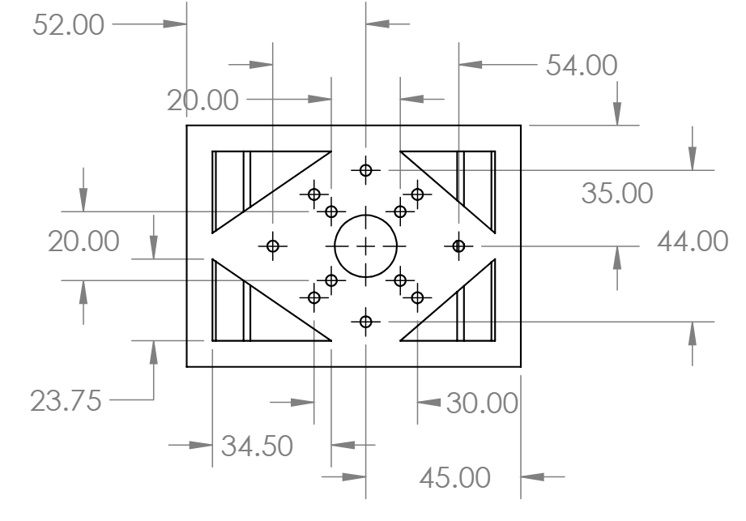

**Figure 7.3.2: Top (Left) and Bottom (Right) Views of the payload-bay bracket designed using SolidWorks**

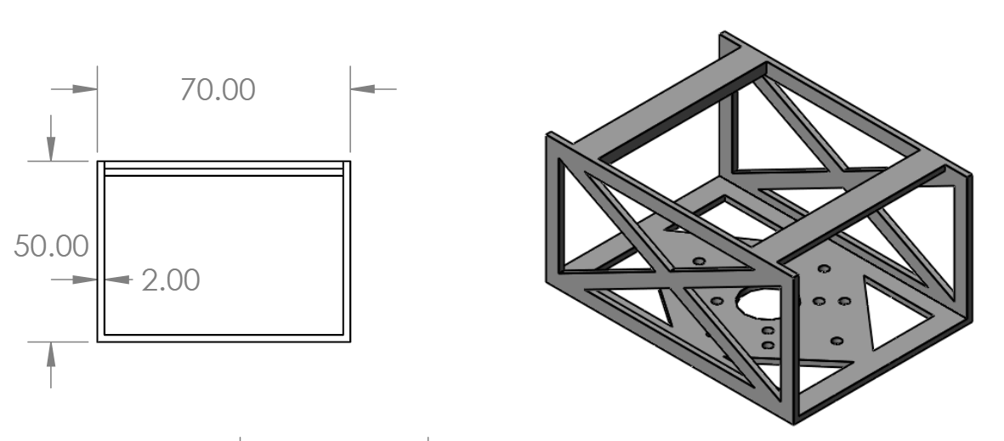

**Figure 7.3.3: Side (Left) and Perspective (Right) Views of the payload-bay bracket designed in SolidWorks**

**Considerations in Hardware Selection**

Several parameters such as size, weight, mechanical noise, compatibility and

optimized flight time were considered during the selection of the components for

this project as shown in the table below:

**Table 7.3.2: Component physical dimensions and weight**

|  |  |  |
| --- | --- | --- |
| Component | Dimensions | Weight |
| Raspberry Pi 3b+ | 86mm X 56mm | 50g |
| Pixhawk | 55mm X 65mm | 38g |
| LIDAR | 85mm X 60mm | 207g |
| Camera | 25mm X 24mm | 3g |
| Front LED | N/A | 4.36g |
| Arm LED | N/A | 3.41g (4) |
| Battery Cage | Will be removed | 12g |
| Top Shell | Will be removed | 12.83g |
| Propellor Guards | N/A | 34.12g |
| Landing gear | Will be removed | 37g |

**Mechanical Feasibility Tests**

To find out the capabilities of the quadcopter, we attached weights to the frame of the MJX Bugs 3 and found that the max payload in factory condition is 320g with a flight time of 8-10 minutes.

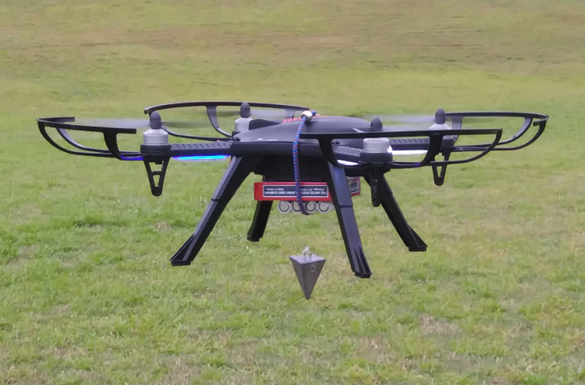

**Figure 7.3.4: Quadcopter maximum payload tests with dummy payload weights**

For the sake of project feasibility verification, a complete payload assembly mockup was constructed both using CAD (SolidWorks) virtually and using actual components physically with all the on-board hardware peripherals that constitute the payload as shown in the Figure 7.3.4 below.

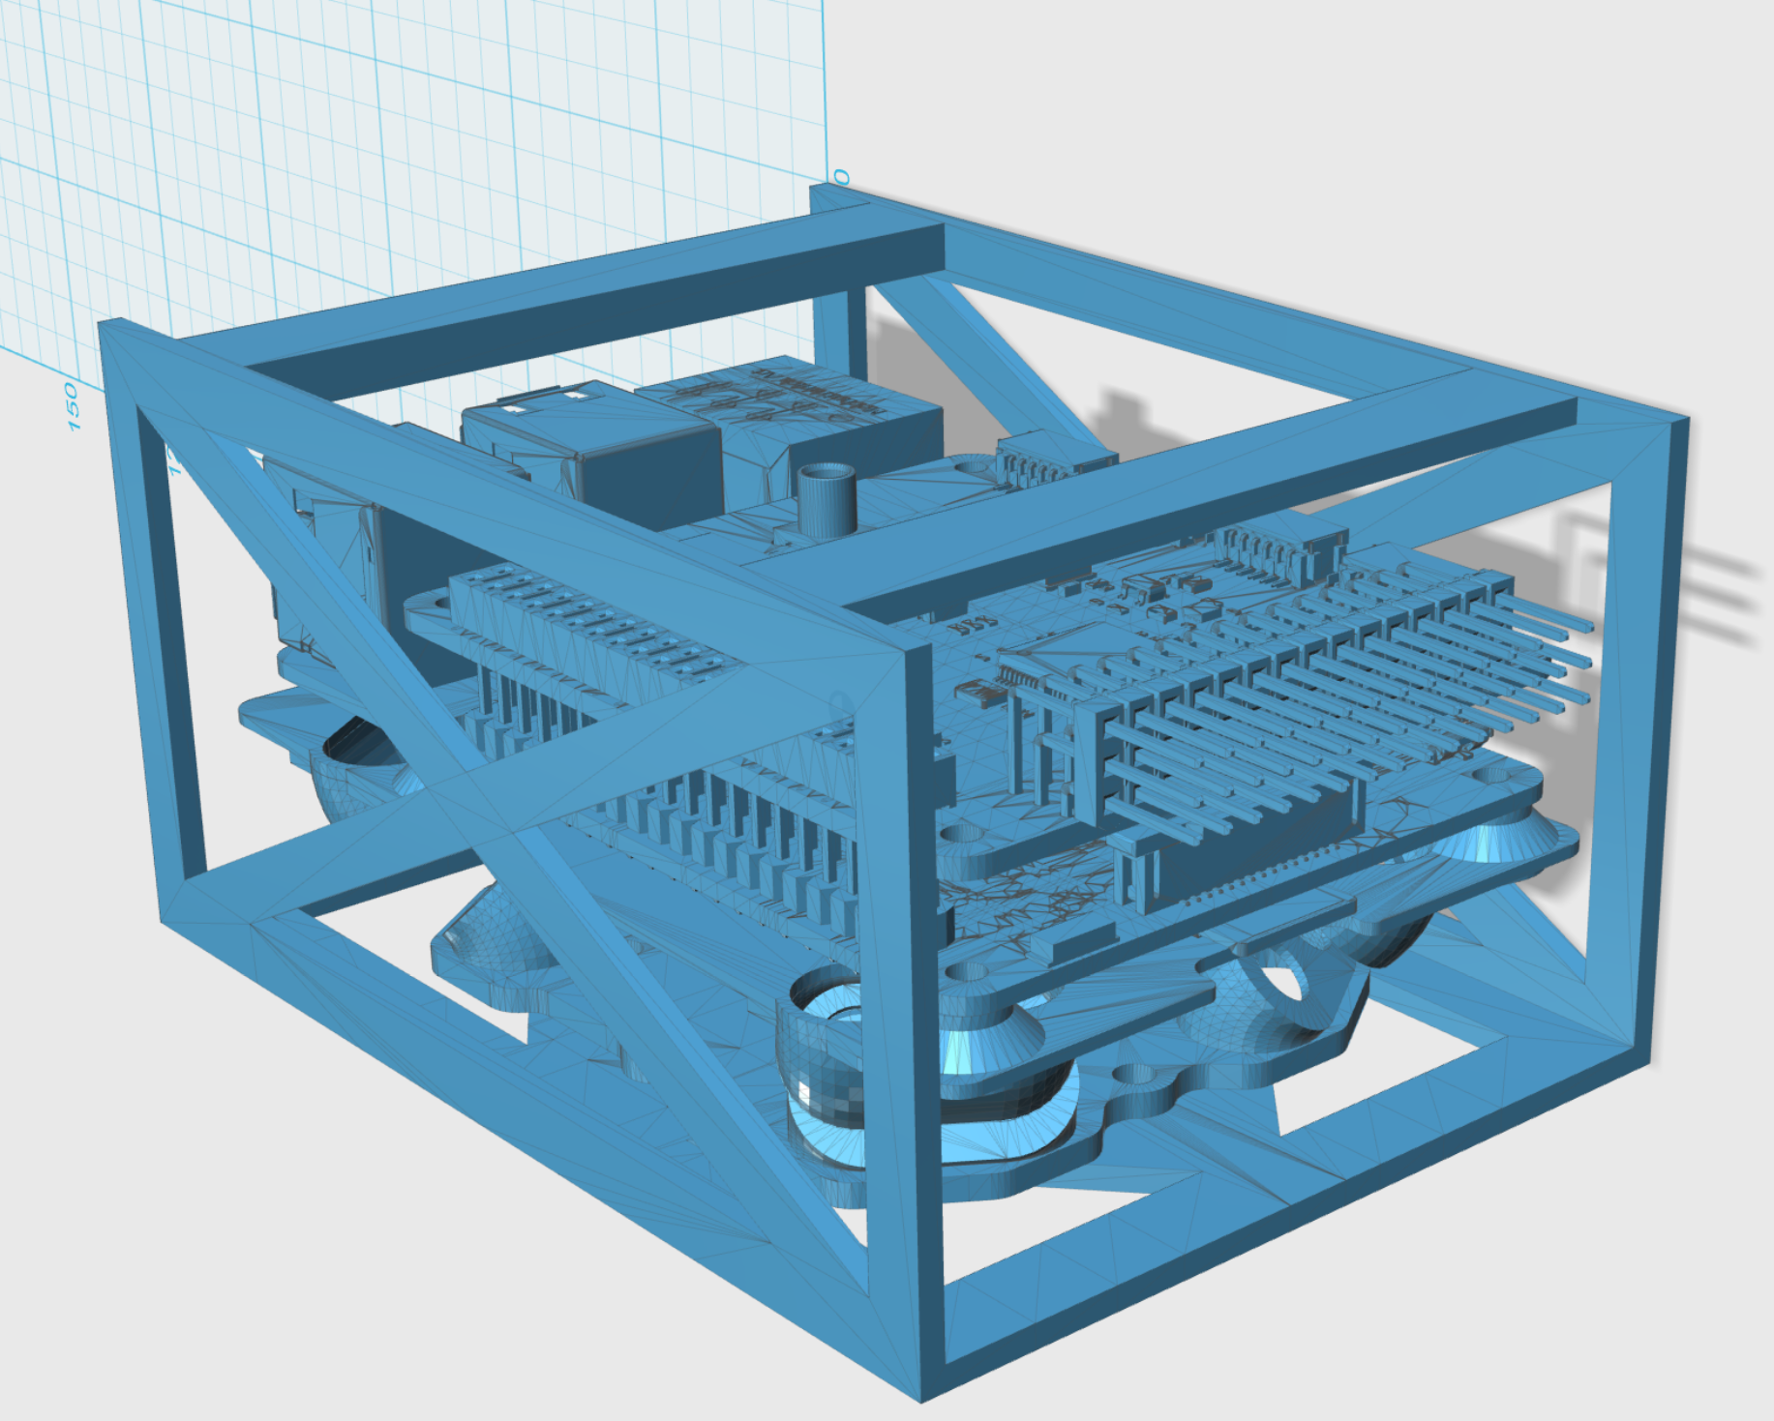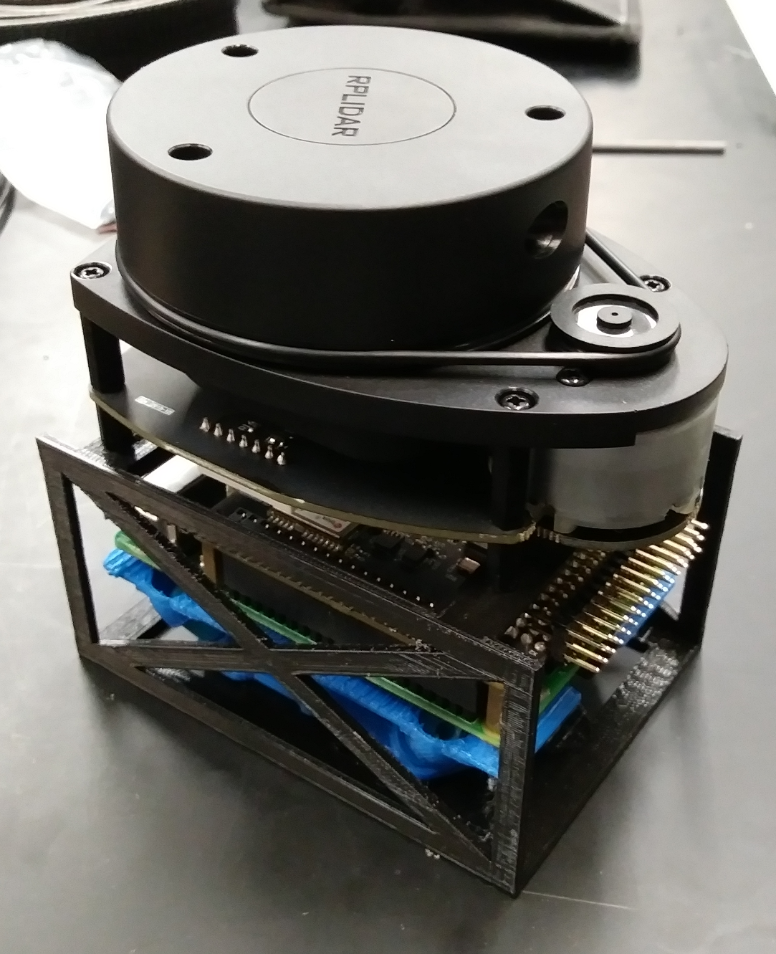

**Figure 7.3.5: Complete payload assembly mockups both using CAD virtually (left) and actual hardware components physically w/ LIDAR on top (right)**

c. Simultaneous Localization and Mapping

The quadcopter was equipped with 2D LIDAR sensor to assist localization of the robot at a fixed altitude inside a floor in the building. The RPLidar A1M8 by Slamtec is a 360 degree 2D LIDAR module that generates a depth point-map at 8000 samples per second. The scanner head on the A1M8 rotates at a minimum of 5.5 Hz and detects depth points up to a range of 12 meters. [10]

The point-map generated by the sensor will then be provided to the SLAM algorithm. The Robot Operating System (ROS) package “Cartographer” will be used to create a low-computation ROS node to be executed on the Raspberry Pi. The “Cartographer” package offers a simple but powerful algorithm for performing real-time 2D SLAM on computationally limited platforms. [11]

The LIDAR-based visual odometry generated by the SLAM algorithm will then be fed into the Extended Kalman Filter (EKF) integrated into the PX4 flight stack to improve state estimation of the platform in the indoor environment. PX4 offers a clean interface for the integration with external localization estimates [8] such as those generated by the ROS-based SLAM node.

The 2D map generated by the Hector SLAM algorithm will be saved finally onto the on-board storage device carried by the quadcopter. This map could then be used as a rapidly generated floor plan of the building by the users of the device such as first responders.

d. Path Planning

The path planning algorithm provides the instructions for the robot to traverse space in safe and obstacle-free paths. Commonly used path planning algorithms include tree-based algorithms such as Rapidly-exploring Random Trees (RRT), RRT* and RRT*-Smart, uninformed search-based algorithms such as Depth First Search and Breadth First Search, and informed search-based algorithms such as A*, D* and their variants.

For the purpose of this project, a 2D RRT will be used as the base algorithm and will be incrementally optimized with improvements provided by RRT* and RRT*-Smart variants. Although RRT does not guarantee optimal path, it does offer probabilistic completeness. The optimizations from RRT* will be used to achieve optimal paths, accelerated by the modifications from RRT*-Smart variant. C++ will be primarily used for the implementation of the RRT based path planning module in form of a ROS node.

The algorithm will first be tested on the Gazebo simulator in a 2D simulation environment. During the final mock-up phase for testing the quadcopter in a maze-like structure, improvements will be made to optimize the time of convergence of the algorithm. The algorithm will be rigorously tested in this maze-like testing environment.

If the RRT based algorithm does not converge fast enough during the flight of the quadcopter, the robot will be allowed to briefly halt and hover to wait for the completion of the path planning iteration. The ArduPilot configuration parameters will be appropriately modified and configured to achieve such behavior as necessary.

* + 1. Flow Charts

Environmental data was received by onboard sensors such as LIDAR and processed by the Raspberry Pi. Based on the flight sensors and LIDAR information, the Raspberry Pi processed this information through flight control algorithms and sent the control signals required to maneuver the quadcopter to the ESCs and motors.

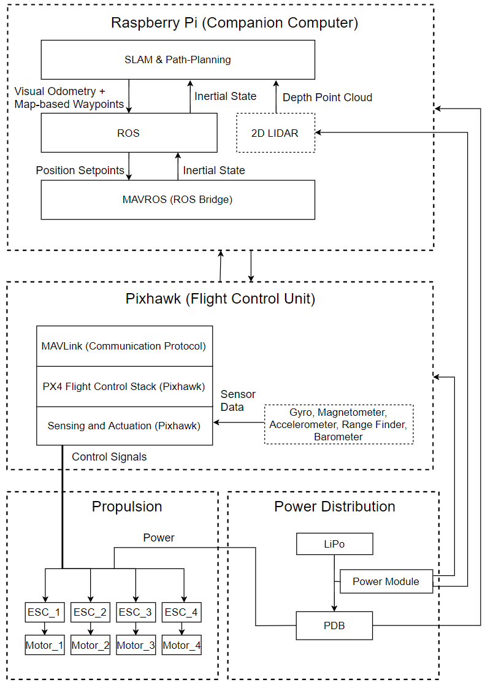

**Figure 7.3.6: Data flow and signals interaction between onboard computer, flight sensor suite, and actuators**

* + 1. Schematics

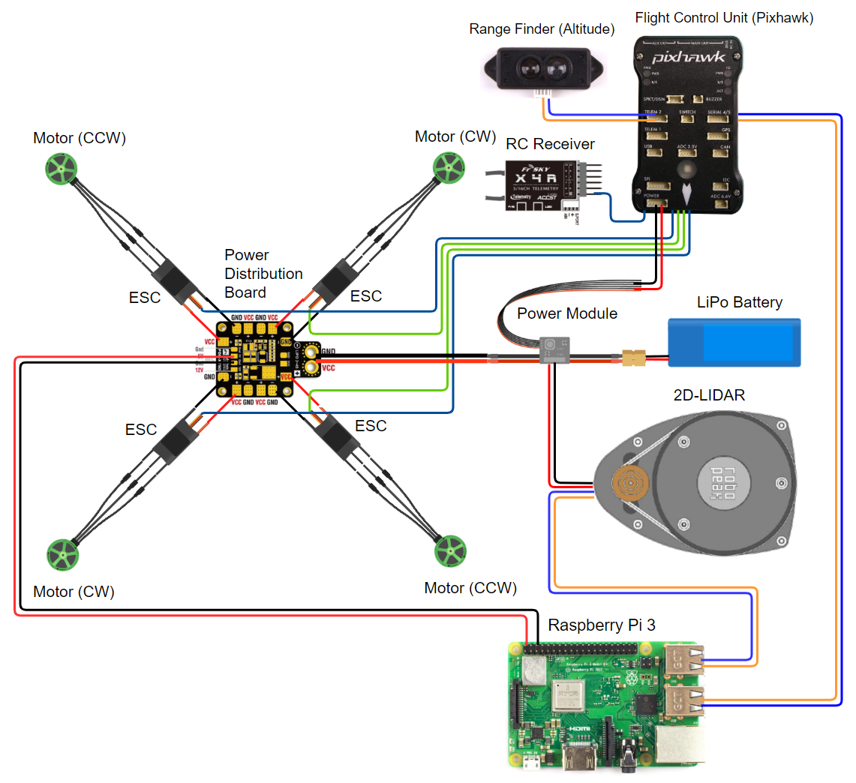

**Figure 7.3.7. Circuit diagram depicting hardware data and power connections**

* + 1. Simulations

Simulations in robotics allow safe and inexpensive techniques for testing the software aspect of the robot. Gazebo is one of the most commonly used simulation software for mobile robotics. A simulation environment on Gazebo will be constructed with support of the dynamics of the ArduPilot stack for quadcopter control algorithms. A Software-In-The-Loop (SITL) approach will be used to simulated the quadcopter control algorithms on Gazebo. ArduPilot offers a convenient interface for programmers to execute the control algorithms in such SITL loops.

The Path Planning algorithm will also be tested separately using C++ on a desktop computer over different obstacle configurations and 2D occupancy grids. The RRT will be tested with different number of nodes to derive a rough estimate of its performance and precision in finding a safe and optimal path for the quadcopter.

The LIDAR-based SLAM algorithm from the “Cartographer” algorithm will also be tested on a Linux workstation with just the RPLidar A1M8 module. ROS will be intensively used a framework for the interactive operation of all the subsystems. The Linux workstation will therefore be equipped with ROS Kinetic during simulation and software testing.

* 1. Brief Discussion of Other Technical Approaches Considered

Multiple approaches were considered during initial project development. The first approach used a single camera paired with a graphically powerful single board computer to perform visual-based SLAM and path-planning. This greatly increased software system design complexity and, due to project time constraints, was instead substituted with a LiDAR based system. A lighter single board computer can be used and LiDAR-based SLAM and path planning algorithms greatly reduce software complexity.

Building the quadcopter from scratch was considered during initial project development stages. Upon further research the team decided to instead purchase a “ready to fly” (RTF) quadcopter due to variability in available quadcopter parts and potential resource consumption required to assemble, program, and tune a custom built drone. We made the decision that an RTF platform would allow for more time and resources to be spent developing software systems and algorithms, which is a priority. There were some variables that we failed to foresee when it came to this choice of platform. The most important was the limited power available in RTF quadcopter systems. Most affordable commercially available quadcopters are designed with a propulsion system tailored for their specific weight and a small payload. Most quads do not offer detailed documentation on their thrust and payload specifications. When we retrofitted the chosen RTF system with the necessary hardware components and sensors, the factory propulsion proved insufficient and more powerful motors and ESCs were necessary. The more powerful drivetrain greatly increased platform stability and provided a flight time that was greater than original goal requirements. .

1. Part List and Budget

**Table 8.1: Part and Price Lists**

|  |  |  |  |  |
| --- | --- | --- | --- | --- |
| **Parts** | **Model** | **Manufacturers** | **Quantity** | **Price** |
| Sensor Suite Board | Pixhawk | Pixhawk | 1 | 200 |
| Flight Computer | Raspberry Pi | Raspberry Pi Foundation | 1 | 50 |
| LIDAR | RPLidar A1M8 | Slamtec | 1 | 120 |
| Quadcopter | Bugs 3 | MJX | 1 | 100 |
| Backup Lipo Batteries | 4S, 14.8 V, 50 C | Tattu | 2 | 50 |
| TX | FS-i6x | FlySky | 1 | 30 |
| RX | X6B (PPM) | FrSky | 1 | 30 |
| Camera | RasPi Cam | Raspberry Pi Foundation | 1 | 40 |
| **Total** |  | **N/A** | **9** | **620** |

1. Gantt Chart

The estimated completion date for the project is 17 March 2019. The project has been broken down into five milestones, each with its own sublistings shown below:

* 1. Project Research
     1. Project Proposal
     2. Project Specification Development
     3. Drone Selection
     4. SLAM and Path-Planning Research
  2. Drone Assembly
     1. Hardware Assembly
     2. Dummy Payload Fitting
     3. Non-Fragile Payload Flight Testing
  3. Install Software on Microcomputer
     1. Select and Acquire Microcomputer and Sensors
     2. Program Microcomputer with SLAM
     3. Program Microcomputer with Path Planning Alg.
     4. Simulation Testing
  4. Integrate Hardware and Software
     1. Install Flight Control Module and Sensor Suite
     2. Non-Flight Diagnostic Testing
     3. Basic Flight Diagnostic Testing
     4. Autonomous Flight Testing
  5. Project completion
     1. Complete Technical Documentation
     2. Complete Project Report

For readability purposes, the Gantt chart is shown in parts to display the expected completion dates of each of the major phases. These phases are listed sequentially to convey a sense of overall project trajectory.

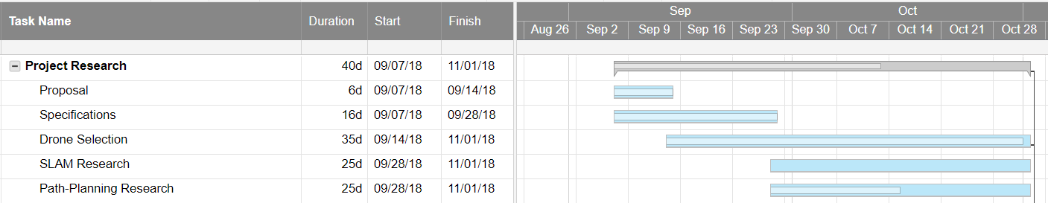

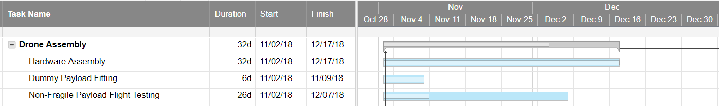

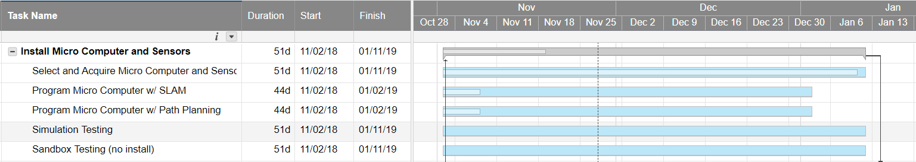

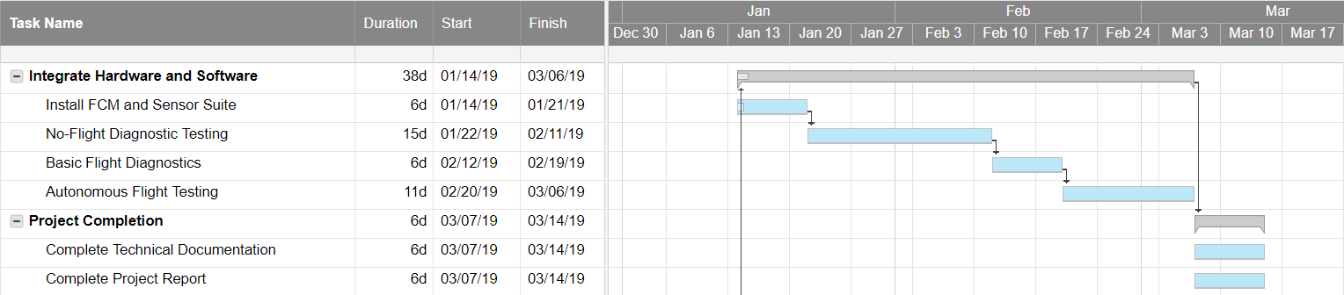

**Figure 9.1: Gantt chart displaying project breakdown with estimated completion time**

1. Testing Approach
2. Hardware Integration Testing

Quadcopters inherently consist of several discrete components spanning both hardware and software aspects of autonomous flight. Motors, ESCs, Propellers, Frame, Power Distribution Board and Flight Controller are only the major constituents of a Quadcopter. For automation and remote control several other components such as sensors, single-board computers, RF receivers and battery monitoring circuits also become necessary. This phase of the project will be focused on the verifying the compatibility and interoperability of all of these components. Additionally, the interfacing of inter-component signals will also be tested by a comprehensive check similar to what a pilot goes through inside a cockpit immediately before takeoff. Following are the major assessments that will be performed in this stage.

1. Component Power Supply Test
2. Radio Communication Test (needed for testing only)
3. Propeller-Motor Thrust Test
4. Center of Mass Positioning Test
5. Signal Interfacing Test
6. Tethered Manual Flight Test
7. Software Simulation Testing

Algorithms are an essential part of any autonomous robot. Control, Localization, Path-Planning and Mapping can only be achieved successfully with the use of specialized algorithms. However, implementation of any algorithm requires rigorous testing over multiple iterations to achieve safe and desirable performance. For the purpose of this project, the following algorithms will be tested individually on off-board computers and inside simulated and virtual environments.

1. ArduPilot SITL (Software-In-The-Loop) Simulation Test
2. *nav_2d* RRT Implementation Test in C++
3. *Cartographer* Simultaneous Localization and Mapping (by Google)
4. Combined Simulation Test
5. Physical Sandbox Testing

Quadcopters are dangerous devices due to their high-speed propellers and flight dynamics. Frequent crashes can also cause damage to the quadcopters themselves. Therefore, a sandboxed real-life mockup environment in the form of a maze-like cardboard structure was considered for complete integrations testing of the quadcopter to limit damage caused to both the quadcopter and its surroundings.

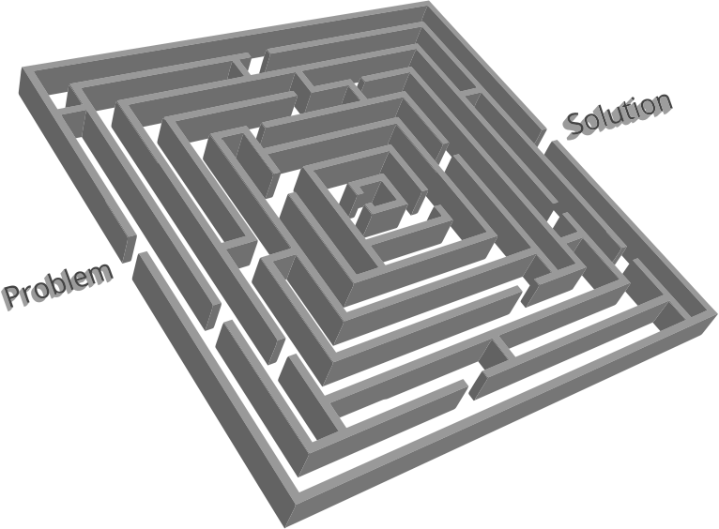

**Figure 10.1: Sandboxed Maze-like Cardboard Structure for Quadcopter Autonomy Tests**

The maze structure would be mockup of a real-life building floor plan and would form an isolated environment for proper testing of autonomous flight. The following will be the factors involved in this phase of testing.

1. Reconfigurable Entrances and Exits to Maze
2. Quick and Easy Prototyping
3. Maze Structural Stability During Wind Conditions
4. Wide and Tall for Quadcopter Maneuvers
5. Final Staging and Acceptance Testing

Once all the previous tests have been successfully performed and the quadcopter has been deemed safe for indoor traversal will the actual deployment testing be performed. In this stage, the quadcopter will be sent into an empty building and expected to generate a reliable 2D map for a given floor autonomously. This test may need to be performed in the absence of mirror and glass surfaces to prevent crashes.

During this stage, all the data generated by the quadcopter in the flight sessions will be captured and later analyzed to introduce improvements in the subsequent flight iterations. System parameters such as current, voltage, temperature and other metrics such as CPU usage and memory usage of the on-board computers will also be monitored during the flight sessions in this stage.

1. Final Product/Project Results

For the quadcopter to be controlled by the path-planning algorithms, and render it fully autonomous, it is necessary to first be capable of utilizing SLAM and PX4’s POSITION_MODE to maintain a constant location within the global/inertial map frame. This was achieved by fusing vision pose data (measured by the on-board LiDAR sensors) and IMU data from the Pixhawk using the EKF built into the PX4 flight stack. After long discussions with PX4 developers it was brought to our attention that this fusion, which relies on pose stamps created by the IMU sensors, was designed specifically for use with 3D vision pose. Our configuration uses a 2D LiDAR scanner and a single point LiDAR altimeter. While this configuration is capable of estimating the 2D location of the system within the map frame, it is not capable of estimating the complete 6 DoF pose (orientation and position) of the aerial robot. Thus the EKF fusion algorithm receives inconsistent values for the Roll and Pitch of the system and is therefore unable to correct for any drifts in local position of the quadcopter.

Though the system is unable to fly autonomously, simply fixing a camera onboard would allow for the vehicle to be remotely piloted and offer a valuable tool for mapping and surveillance. Military and first responders could remain safely outside the hazardous area and receive instantaneous visual feedback on conditions inside, while the quadcopter simultaneously produces a 2D map of the building that can be used for rescue or entry plans.

The first floor of the HMCSE building was chosen as the testing ground for the mapping and integration testing of the system. The drone was able to map the first floor starting from the end of one of the hallways to the opposite end of the other hallway perpendicular to the first in about 3 minutes. A total flight of 6 minutes was performed to also allow the quadcopter to safely maneuver back to its starting location in another 3 minutes from the innermost section of search inside the building. The final result from the mapping has been included in the figure below. The map in the figure offers a high resolution and a tolerance of about 10 cm from the original distances between walls and door sizes. .

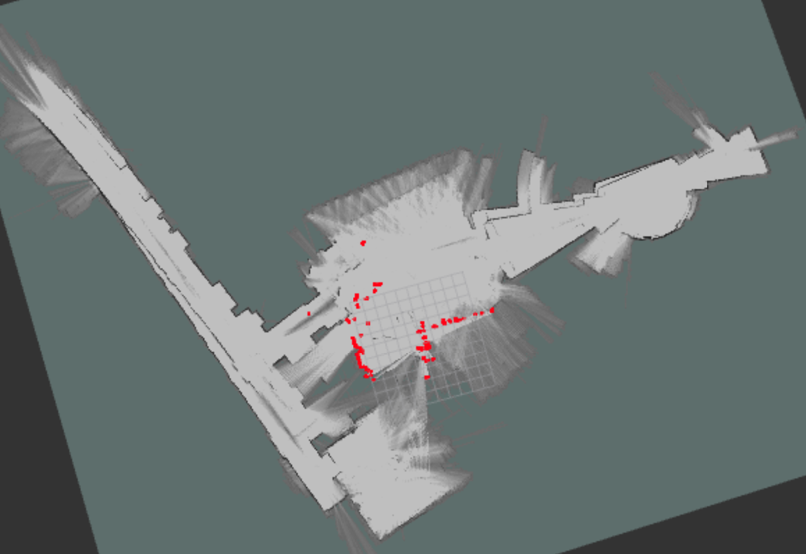

**Figure 12.1: Mapping generated by quadcopter on the first floor of the HMCSE building in about 3 minutes to a resolution of about 10 cm.**

1. Flow Chart of Design Process

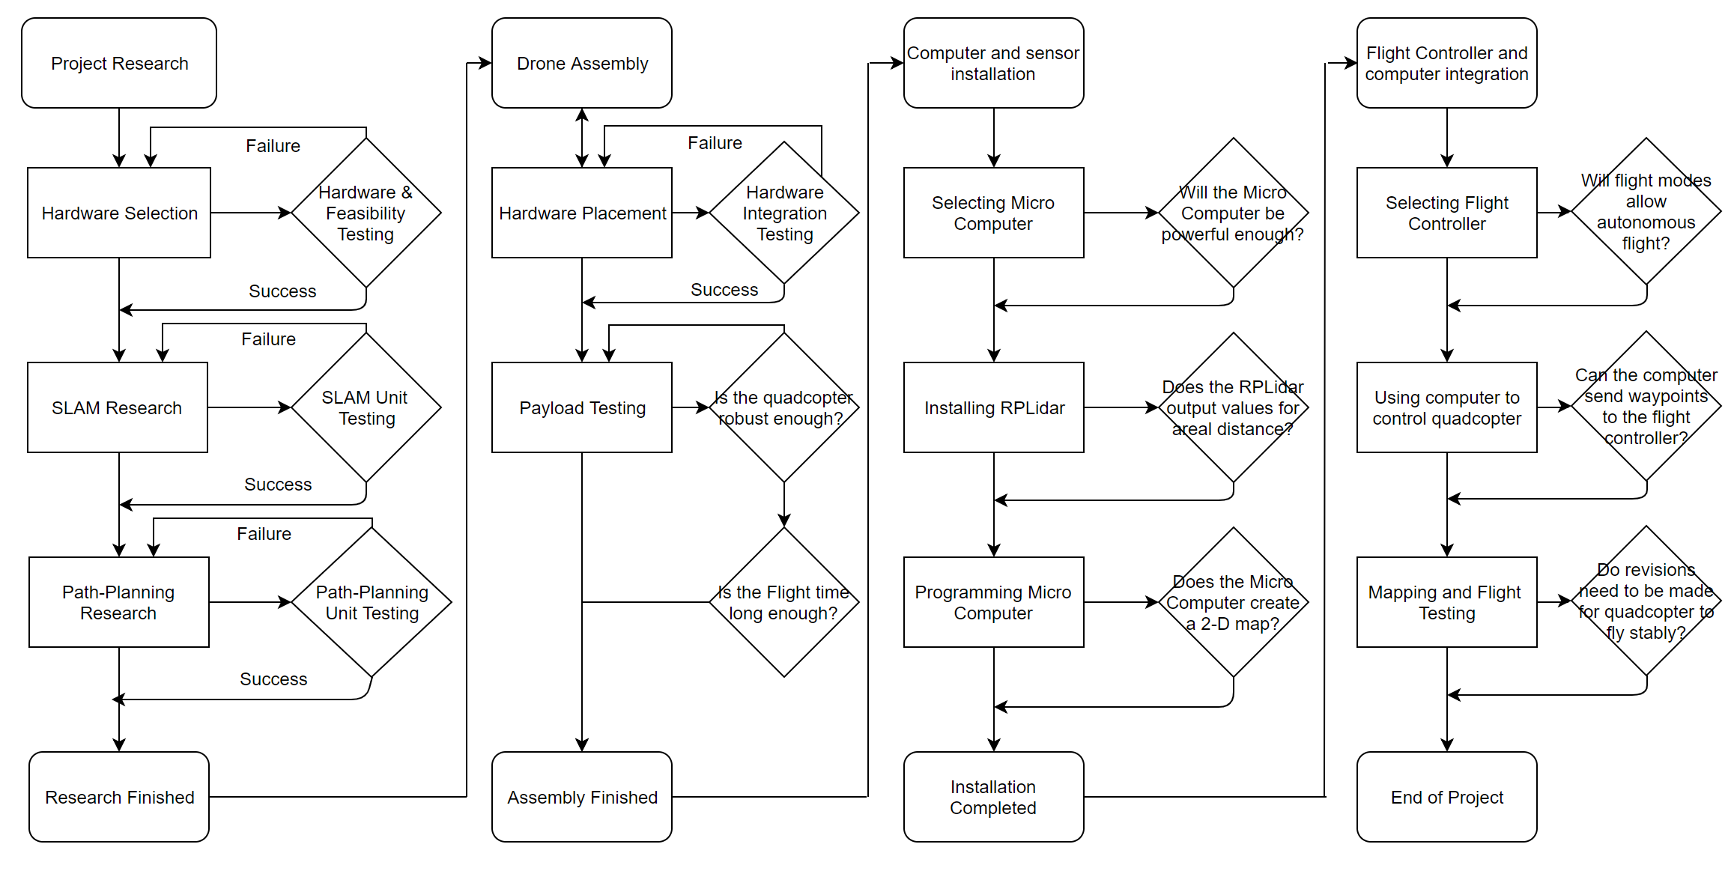

**Figure 7.3.x: Flow Chart for Design and Testing Process**

1. Conclusion

This project on mapping and surveillance using a micro-aerial vehicle was implemented over a total period of two semesters. Research and initial design was accomplished in the first semester as the first sprint of the project development cycle. Implementation and testing were accommodated in the second sprint.

**Mapping**

The quadcopter is now capable of generating a 2D map of a single floor of an unknown building with a total flight time of about 10 mins. The quadcopter stores the map on the flash storage available on-board. The map can be retrieved once the quadcopter is physically back at an accessible location outside the building.

**First-Person View**

The current state of the project provides a first-person view interface with an on-board camera module which streams real-time video feed taken in the perspective of the quadcopter frame of reference.

**Maneuverability**

The miniature size allows this micro-aerial vehicle provides high degree of maneuverability as well as sufficient agility to traverse through hallways and move through open doors and windows.

**Limitations**

The LIDAR-based mapping technique used is limited to buildings with non-transparent surfaces and breaks down in the presence of glass and mirror surfaces due to undesirable reflection and refraction of the LIDAR rays.

1. Assessment of Math, Science and Engineering Topics

**Table 14.1: Assessment of Math, Science and Engineering Topics**

|  |  |  |  |  |
| --- | --- | --- | --- | --- |
| **Topics** | Bhavyansh | James | Scotty | Bryan |
| CAD/modelling/simulations | **3** | **2** | **2** | **4** |
| Chemistry courses | **1** | **1** | **1** | **1** |
| Circuits | **4** | **4** | **4** | **4** |
| Communications | **3** | **3** | **3** | **3** |
| Computer Architecture | **3** | **2** | **2** | **3** |
| Control Systems | **4** | **4** | **4** | **4** |
| Digital Design | **4** | **3** | **3** | **4** |
| Electromagnetic | **4** | **4** | **4** | **4** |
| Electronics | **3** | **3** | **3** | **3** |
| Engineering Software tools | **1** | **1** | **1** | **1** |
| Fluid/Thermodynamic systems | **2** | **2** | **2** | **2** |
| Image Processing | **3** | **4** | **3** | **4** |
| Industrial/Manufacturing Engineering | **1** | **1** | **1** | **1** |
| Material Science | **3** | **3** | **3** | **3** |
| Math courses | **4** | **4** | **4** | **4** |
| Mechanical Engineering | **3** | **4** | **4** | **4** |
| Microprocessors/Interfacing/Embedded Systems | **4** | **4** | **4** | **4** |
| PC Board | **2** | **3** | **3** | **2** |
| Project Management | **4** | **3** | **2** | **4** |
| Physics courses | **4** | **4** | **4** | **4** |
| Power Engineering | **2** | **4** | **4** | **2** |
| Programming | **4** | **3** | **3** | **4** |
| Signal and Systems | **4** | **4** | **4** | **4** |
| Soldering/welding | **4** | **4** | **4** | **4** |
| Statics and Dynamics Course | **4** | **4** | **4** | **4** |
| Statistics | **2** | **2** | **2** | **2** |
| System integration | **4** | **4** | **4** | **4** |
| Very Large Scale Integration (VLSI) | **1** | **1** | **1** | **1** |
| Others: List | SLAM, 3D Printing | Ethics, Video Editing | Safety, First-Aid | Scripting, Path-planning |

1. Team Activity Report

**Table 15.1: Team Activity Report – Summary of Contrbutions by Team Members**

|  |  |  |  |  |
| --- | --- | --- | --- | --- |
|  | Team Members | | | |
| Sections | Name 1 | Name 2 | Name 3 | Name 4 |
| Abstract | James | Bryan |  |  |
| 1. Introduction | James | Scotty |  |  |
| 1. Problem Definition | Bhavyansh | Bryan | Scotty | James |
| * 1. Problem/Need | Bhavyansh | Bryan |  |  |
| * 1. Intended user(s) and use(s) | Bhavyansh | Bryan |  |  |
| * 1. Assumptions and limitations | Bhavyansh | Scotty |  |  |
| 1. Design Objectives | Bhavyansh | Scotty |  |  |
| 1. End-Product Description | James |  |  |  |
| 1. Design constraints | James | Bhavyansh | Scotty |  |
| * 1. Economical | James |  |  |  |
| * 1. Environmental | James | Bhavyansh |  |  |
| * 1. Social and Political | James | Bryan |  |  |
| * 1. Ethical | James | Bryan |  |  |
| * 1. Health and Safety | James | Bhavyansh |  |  |
| * 1. Manufacturability and Sustainability | James |  |  |  |
| 1. Engineering Standards | Scotty |  |  |  |
| 1. Technical Approach | James | Scotty | Bhavyansh | Bryan |
| * 1. Functional Block diagrams | Bhavyansh | James |  |  |
| 7.2 Functional Requirements for Blocks | James | Scotty | Bhavyansh | Bryan |
| 7.3 Technical Details | Scotty | James | Bhavyansh | Bryan |
| * + 1. Theory and Calculations | Scotty | James | Bryan |  |
| * + 1. Flow Charts | Bhavyansh | James | Scotty |  |
| * + 1. Schematics | James | Bhavyansh |  |  |
| 7.3.4 Simulations | Bhavyansh | Bryan |  |  |
| 7.4 Other Approaches | James | Bryan |  |  |
| 1. Part List and Budget | Scotty | Bhavyansh | Bryan |  |
| 1. Gantt Chart | Bryan |  |  |  |
| 1. Testing Approach | Bhavyansh | James |  |  |
| 1. Final Product/Project Results | James |  |  |  |
| 1. Flow Chart of Design Process | Scotty |  |  |  |
| 1. Conclusion |  |  |  |  |
| References | Bhavyansh |  |  |  |

Appendix A (Resumes and Team Member Profile Forms)



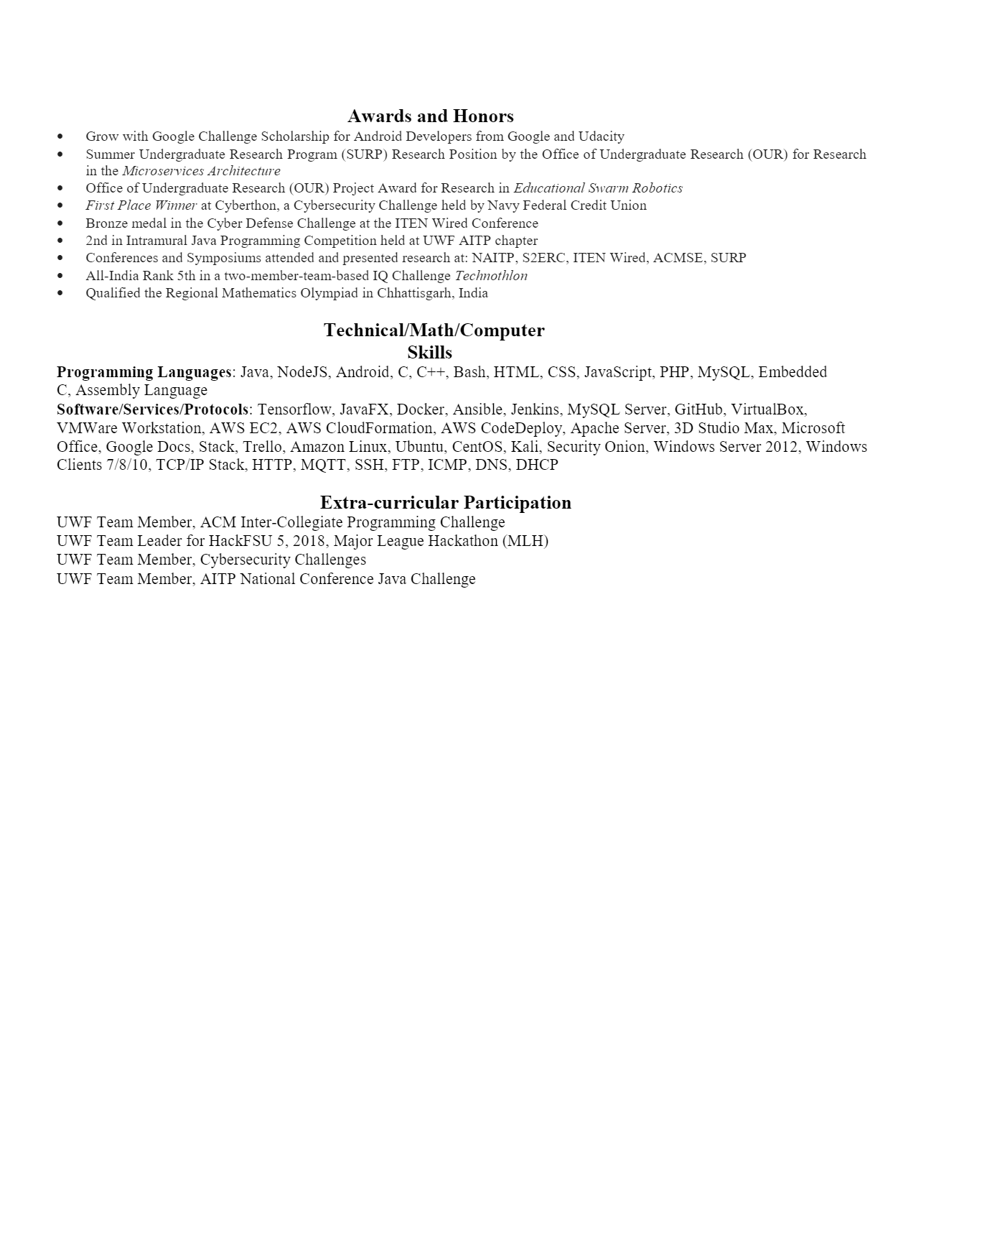



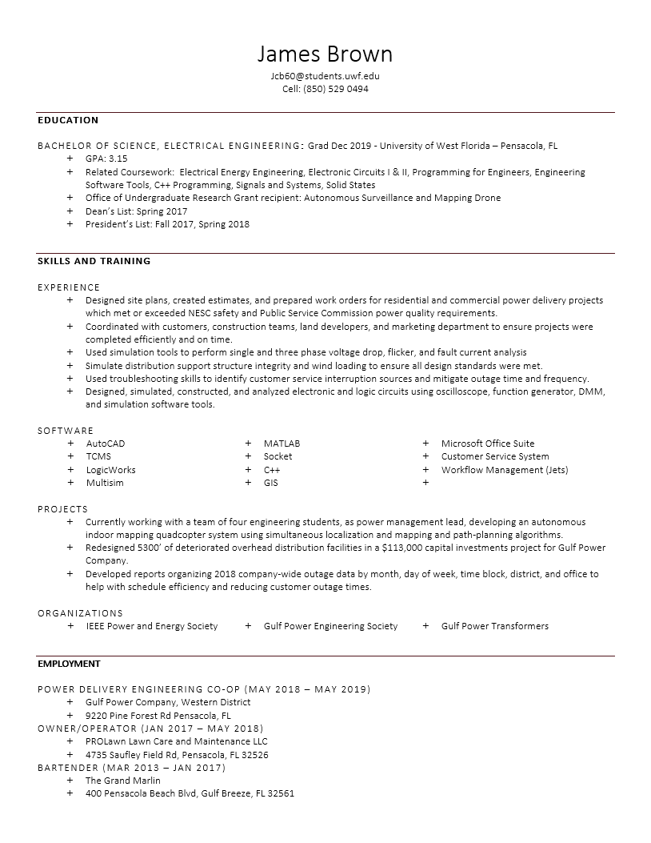





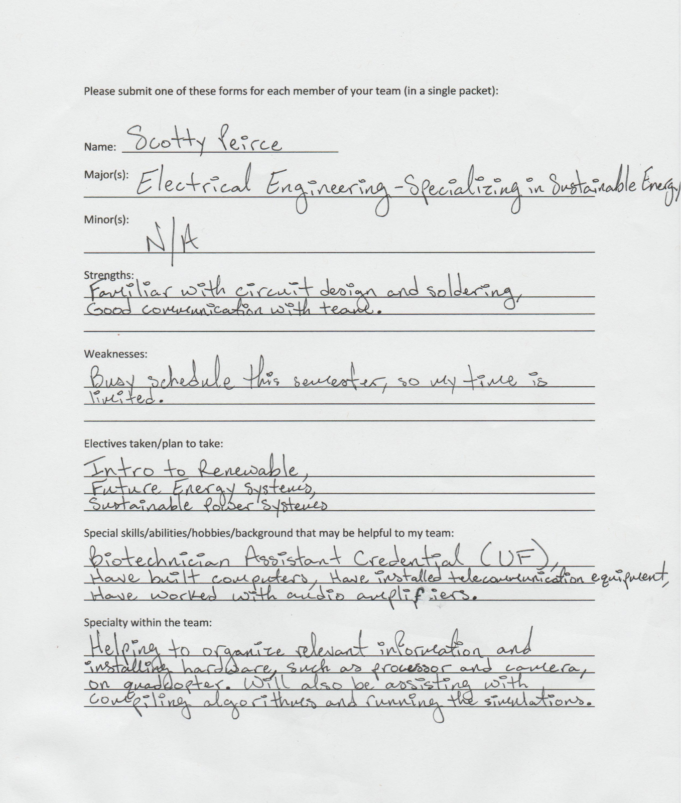

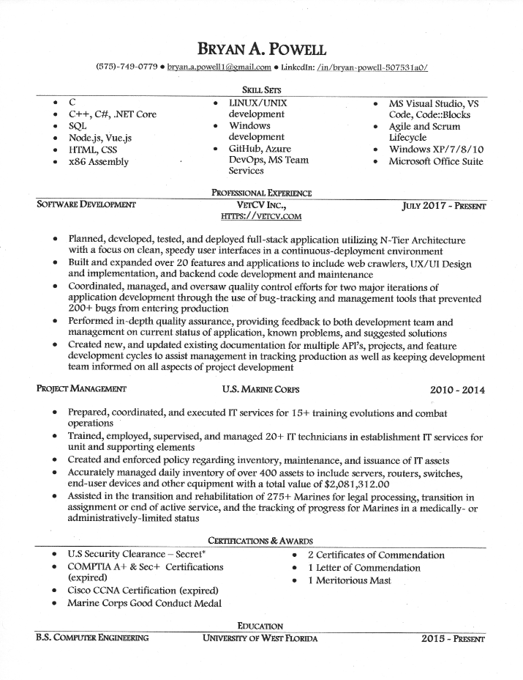

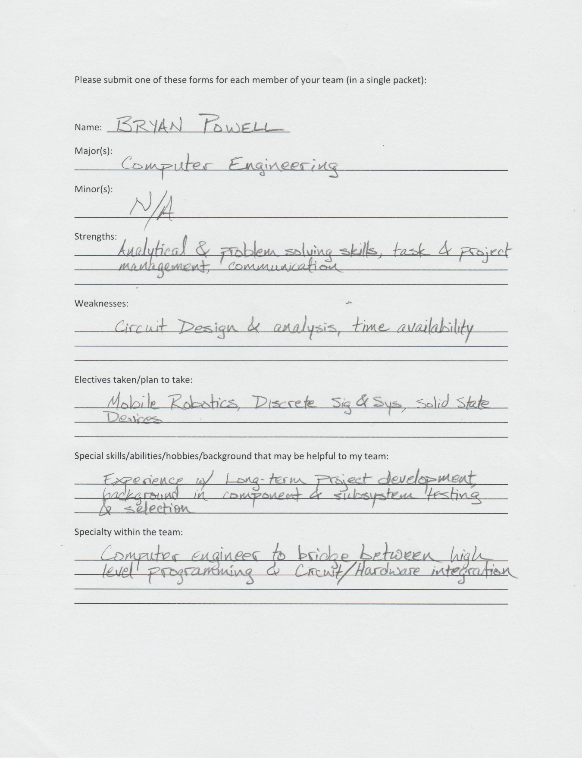

Appendix B (CAD Designs)

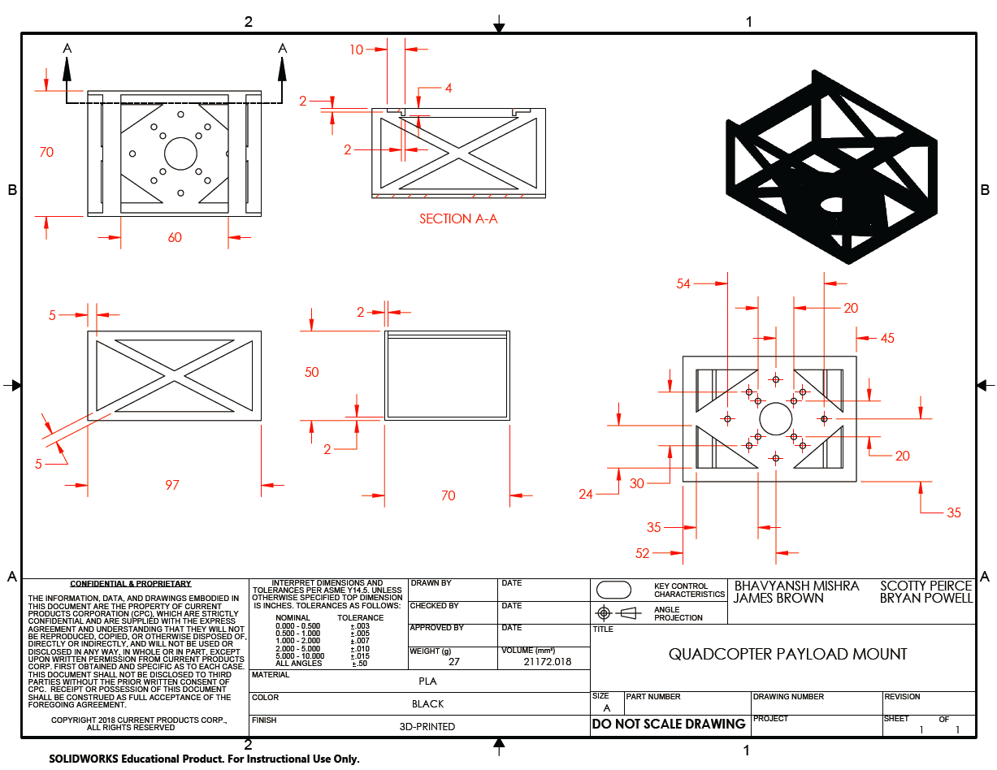

Bibliography

[1] W. Hess, D. Kohler, H. Rapp and D. Andor, "Real-time loop closure in 2D LIDAR SLAM," *2016 IEEE International Conference on Robotics and Automation (ICRA)*, Stockholm, 2016, pp. 1271-1278.

doi: 10.1109/ICRA.2016.7487258

[2] D. Shen, Y. Huang, Y. Wang and C. Zhao, "Research and Implementation of SLAM Based on LIDAR for Four-Wheeled Mobile Robot," *2018 IEEE International Conference of Intelligent Robotic and Control Engineering (IRCE)*, Lanzhou, 2018, pp. 19-23.

doi: 10.1109/IRCE.2018.8492968

[3] C. Zhang, J. Wang, J. Li and M. Yan, "2D Map Building and Path Planning Based on LiDAR," *2017 4th International Conference on Information Science and Control Engineering (ICISCE)*, Changsha, 2017, pp. 783-787.

doi: 10.1109/ICISCE.2017.167

[4] X. Song and S. Hu, "2D path planning with dubins-path-based A∗algorithm for a fixed-wing UAV," *2017 3rd IEEE International Conference on Control Science and Systems Engineering (ICCSSE)*, Beijing, 2017, pp. 69-73.

doi: 10.1109/CCSSE.2017.8087897

[5] <http://ardupilot.org/copter/docs/common-navio2-overview.html>

[6] <https://github.com/emlid/hardware/blob/master/Navio2.STL>

[7] <https://www.thingiverse.com/thing:1701186>

[8] <http://ardupilot.org/copter/docs/indoor-flying.html>

[9] <https://www.instructables.com/id/Step-by-step-Guidance-to-Build-a-Drone-From-Scratc/>

[10] <https://www.robotshop.com/media/files/pdf/rplidar-a1m8-360-degree-laser-scanner-development-kit-datasheet-1.pdf>

[11] <http://wiki.ros.org/rplidar>

Table of Figures

|  |  |
| --- | --- |
| Number | Figure Description |
| 7.1.1 | Functional block diagram |
| 7.3.1 | Architecture of Power Distribution and Flow |
| 7.3.2 | Top (Left) and Bottom (Right) Views of the payload-bay bracket designed using SolidWorks |
| 7.3.3 | Side (Left) and Perspective (Right) Views of the payload-bay bracket designed in SolidWorks |
| 7.3.4 | Quadcopter maximum payload tests with dummy payload weights |
| 7.3.5 | Complete payload assembly mockups both using CAD virtually (left) and actual hardware components physically w/ LIDAR on top (right) |
| 7.3.6 | Data flow and signals interaction between onboard computer, flight sensor suite, and actuators |
| 7.3.7 | Circuit schematic diagram depicting the Raspberry Pi, Navio2, ESCs, Motors, Power Module and the LiPo battery |
| 9.1 | Gantt chart displaying project breakdown with estimated completion time |

Table of Tables

|  |  |
| --- | --- |
| Number | Table Description |
| 7.2.1 | Functional Requirements and Specifications for Power Distribution |
| 7.2.2 | Functional Requirements and Specifications for Mechanical Design and Feasibility |
| 7.2.3 | Functional Requirements and Specifications for Localization and Mapping |
| 7.2.4 | Functional Requirements and Specifications for Path-Planning |
| 7.3.1 | Max system power requirements |
| 7.3.2 | Component physical dimensions and weight |
| 8.1 | Part and Price Lists |
| 14.1 | Assessment of Math, Science and Engineering Topics |
| 15.1 | Team Activity Report – Summary of Contributions by Team Members |